Contents

Account Management 3

Register New Account 3

Logging In 4

Change Password 5

Logout 5

Profile Management 6

View Profile 6

Edit Profile, Mailing Address, and Shipping Address 6

Add Credit Card 7

Delete Credit Card 8

View Wishlist 9

Register for Event 9

Game Store 11

View Game Details 11

Add to Wishlist 11

Remove From Wishlist 11

Add to Cart 12

Delete From Cart 12

Download Game 13

Search for Game 13

Cart 14

View cart 14

Edit Cart 14

Check Out 15

Submit order 16

Friends 17

View Friends 17

Add Friend 18

Delete friend 19

View friend’s wish list 20

Library 20

Rate game 20

Add review 22

# Account Management

## Register New Account

On the Home page, click on the “Members” link in the navigation bar.

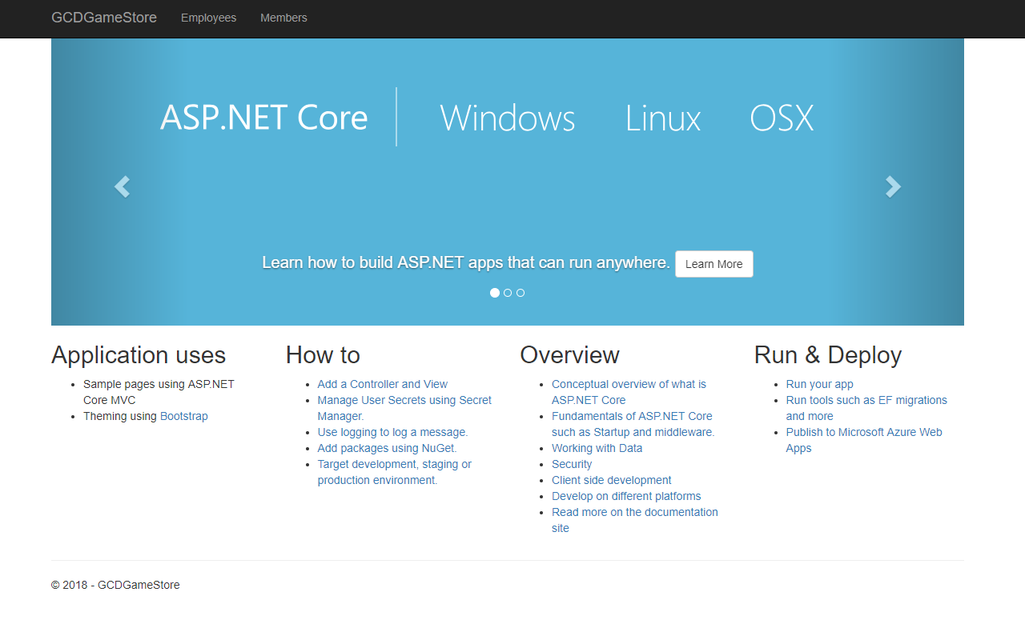

This will bring up the log in page. Click the “Register New Account” button.

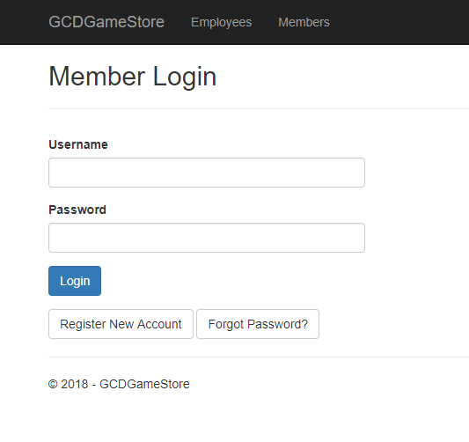

This will bring up a form to enter the necessary information to create a new account.

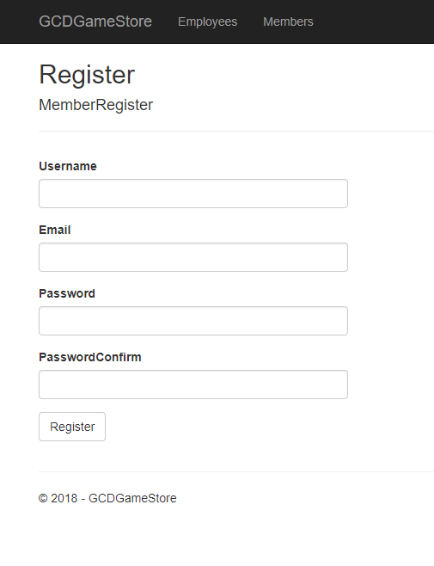

Enter the account information and click on the “Register” button.

## Logging In

On the Home page, click on the “Members” link in the navigation bar.



This will bring up the login page. Enter your information and click on the “Login” button.



## Change Password

After logging in the profile page is displayed. Select the “Change password” link located at the bottom.

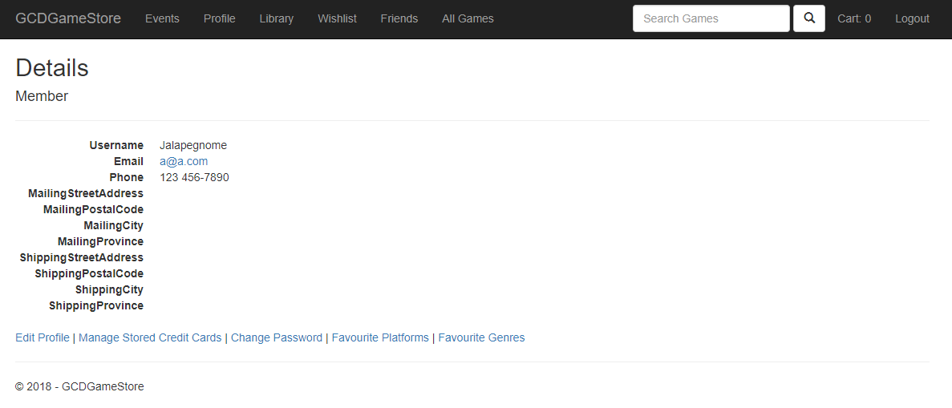

## Logout

In the upper right of the navigation bar while on the profile page, select the “Logout” link.

# Profile Management

## View Profile

When logged in, click on the “Profile” link in the navigation bar.

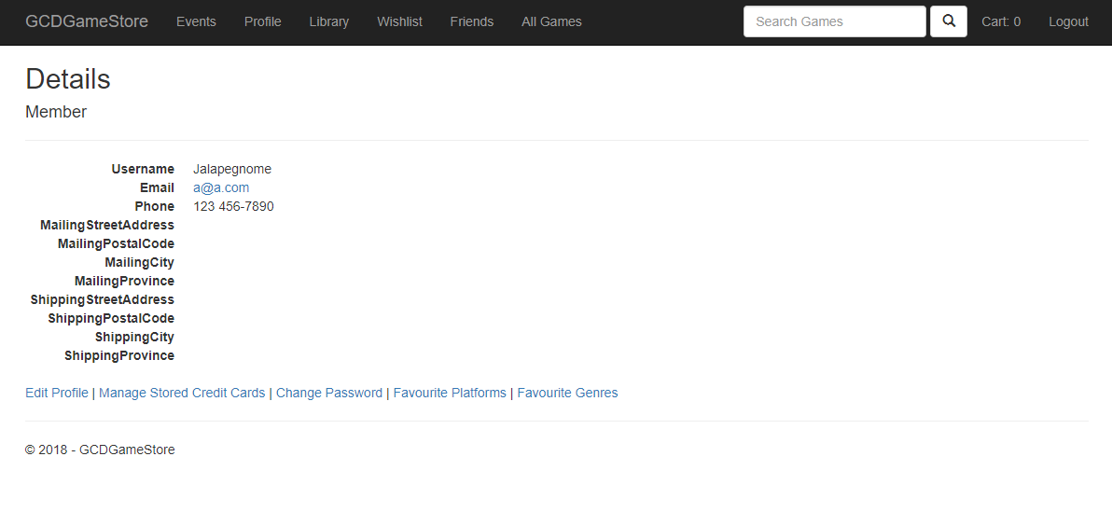

## Edit Profile, Mailing Address, and Shipping Address

While logged in and on the profile page, select the “Edit Profile” link at the bottom of the page.



This will bring up the edit profile form, which will allow for filling out profile information, as well as the mailing and shipping addresses.

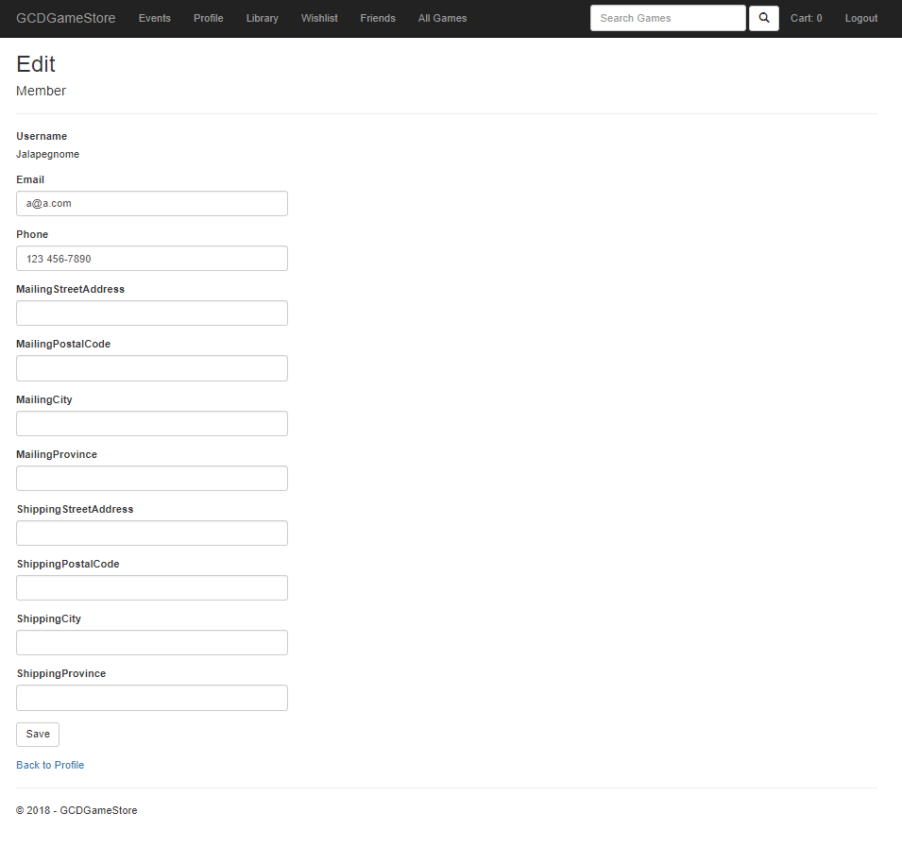

After filling out any information changes, click on the “Save” button at the bottom of the form.

## Add Credit Card

From the profile page, click on the “Manage Stored Credit Cards” link at the bottom of the page, next to the “Edit Profile” link. This will take you to the following page:

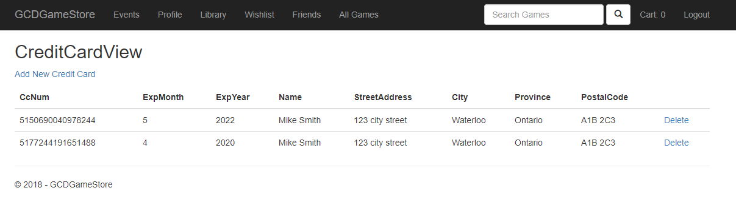

Click on the “Add New Credit Card” link below the page title. This will bring up the Create Credit Card form.

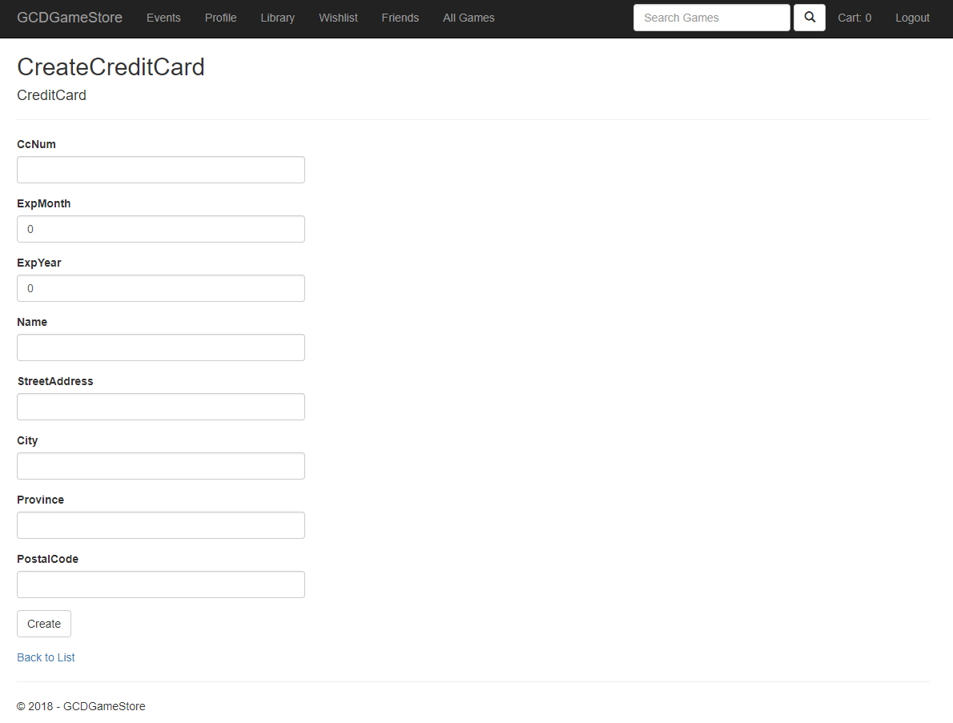

After entering the required information, click on the “Create” button at the bottom of the page.

## Delete Credit Card

After following the “Manage Stored Credit Cards” link from the profile page, click on the “Delete” link next to the credit card entry you wish to delete.



This will take you to a deletion confirmation page.

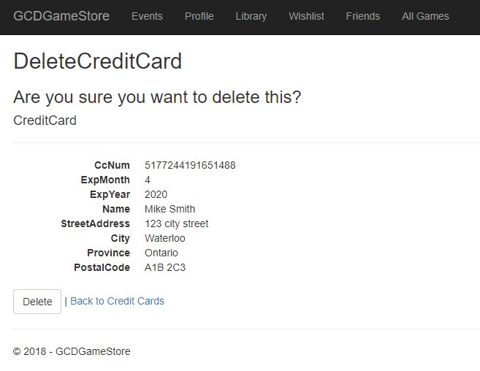

Click on the “Delete” button at the bottom to delete the credit card record.

## View Wishlist

While logged in, click on the “Wishlist” link located in the navigation bar.

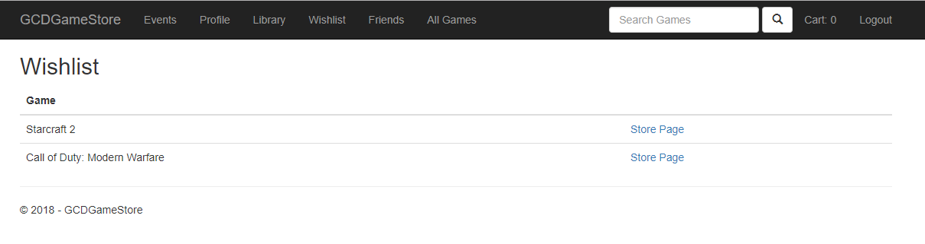

## Register for Event

While logged in, click on the “Events” link located in the navigation bar.

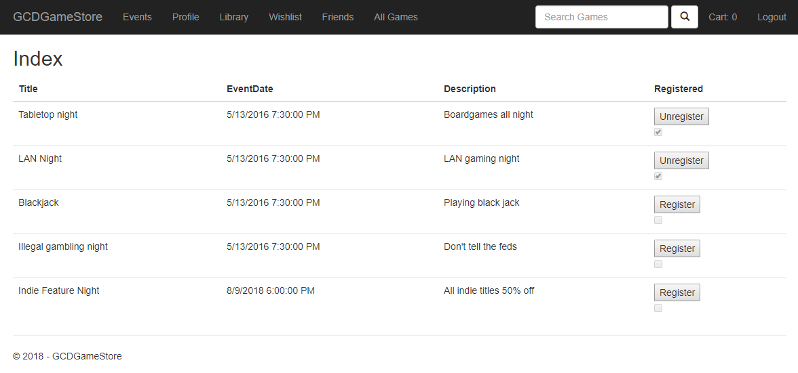

For any events not currently registered for, click on the “Register” button to the right of the entry to register for it.

# Game Store

## View Game Details

While logged in, click on the “All Games” link located in the navigation bar. This will bring up a listing of all available games.

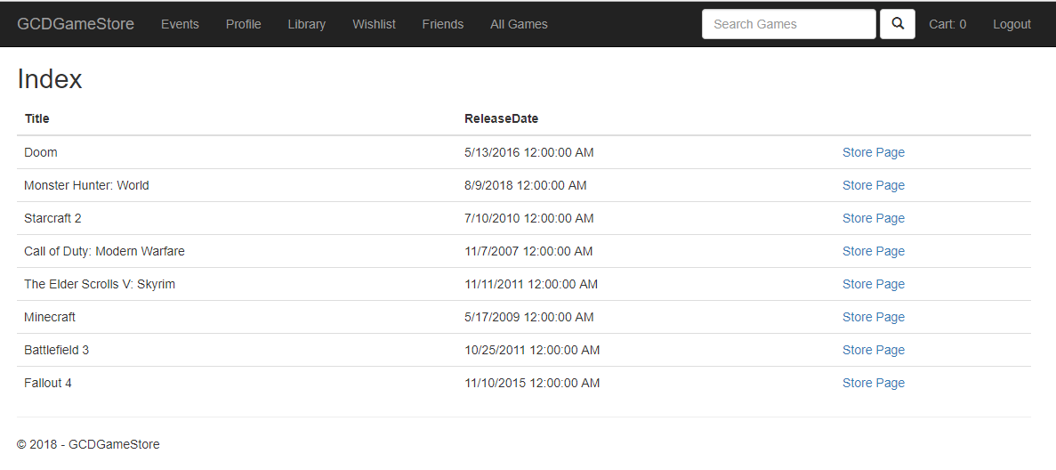

Click on the “Store Page” link to the right of a game listing to view its store page.

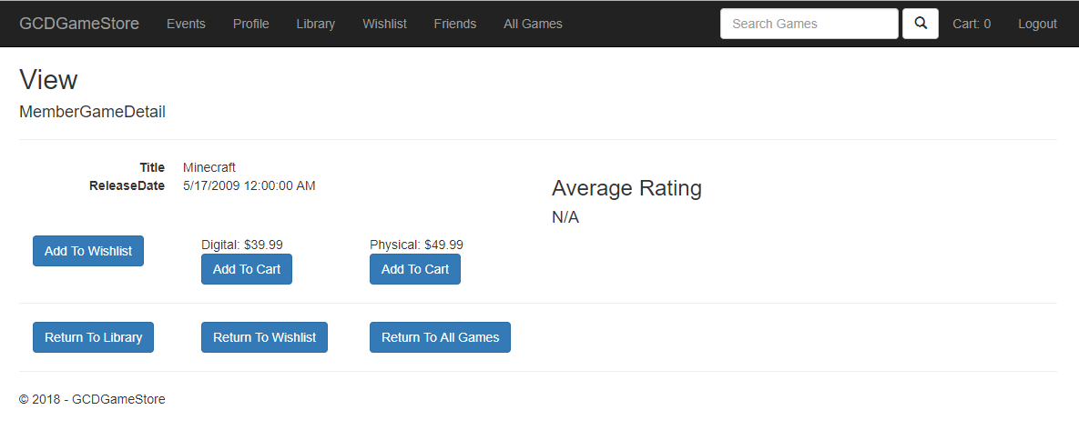

## Add to Wishlist

On the store page for a game which is not in the library and not already on the Wishlist, click on the “Add To Wishlist” button to add it.

## Remove From Wishlist

If a game is presently on the Wishlist, its store page will look as follows:

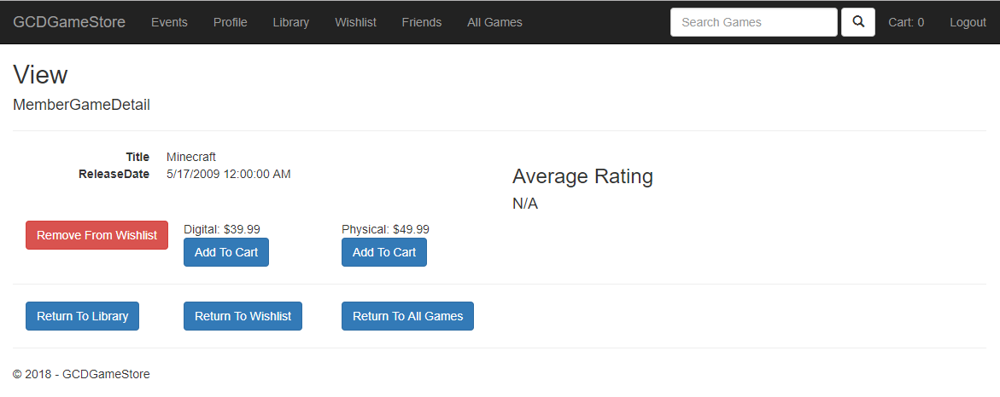

To remove the game from the Wishlist, click on the “Remove From Wishlist” button.

## Add to Cart

If a game is not owned and is not already on a user’s cart, the store page will look as follows:



To add to the cart, click on the “Add To Cart” button under the desired version.

## Delete From Cart

If a game is already added to the cart, its store page will look as follows:

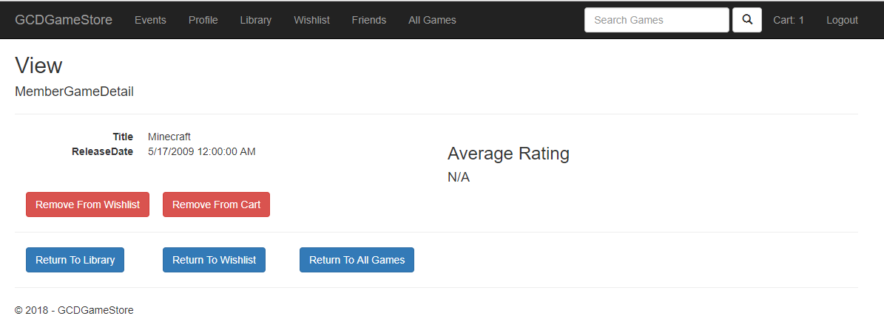

To remove the game from the cart, click on the “Remove From Cart” button.

## Download Game

If a game is owned, the store page will look as follows:

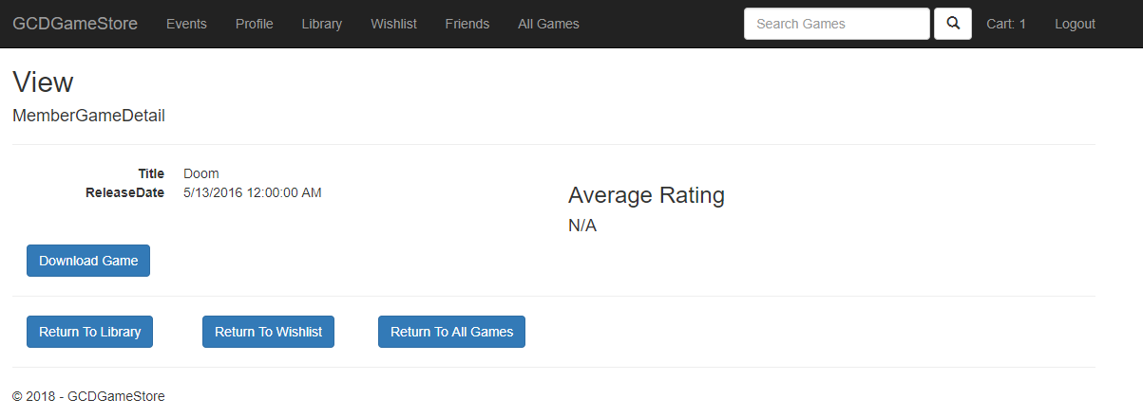

To initiate a download, click on the “Download Game” button, which will bring up the download page.

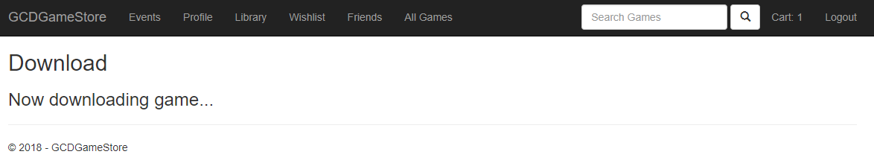

## Search for Game

In the navigation bar, there is a text box with placeholder text: “Search Games”

Enter the desired text and hit enter or the search button to the right of the field.

# Cart

## View cart

Once member logged in, click “Cart” button next to search game bar in the navigation bar.

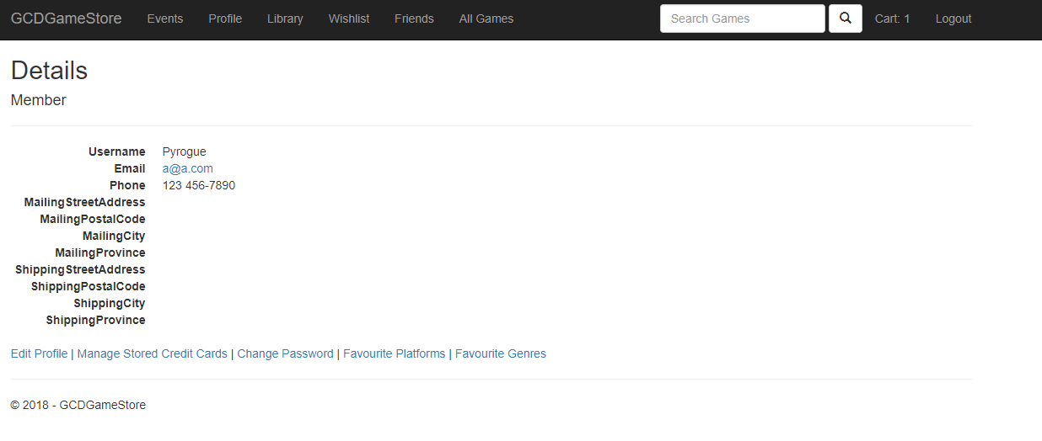

The cart page is displayed.

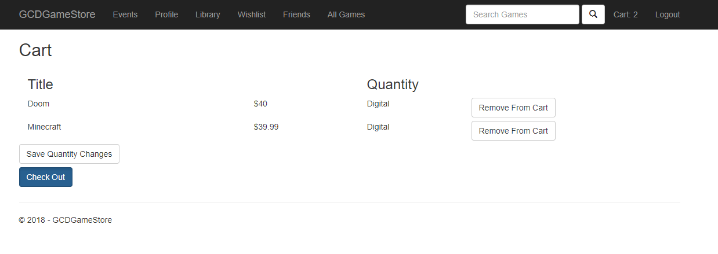

## Edit Cart

In the cart page, enter a number in the quantity to edit the number of physical copies. Click “Save Quantity Changes” to finish editing cart.

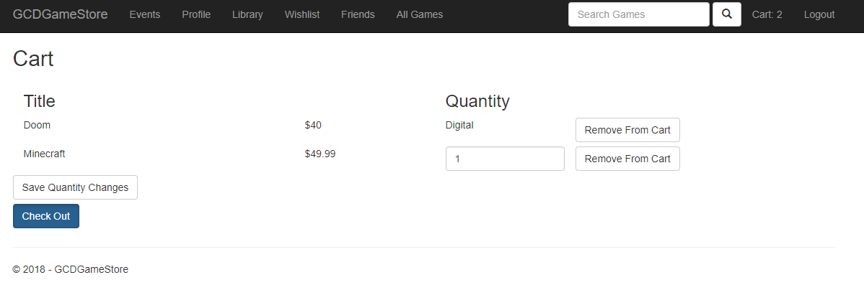

Updated cart is displayed.

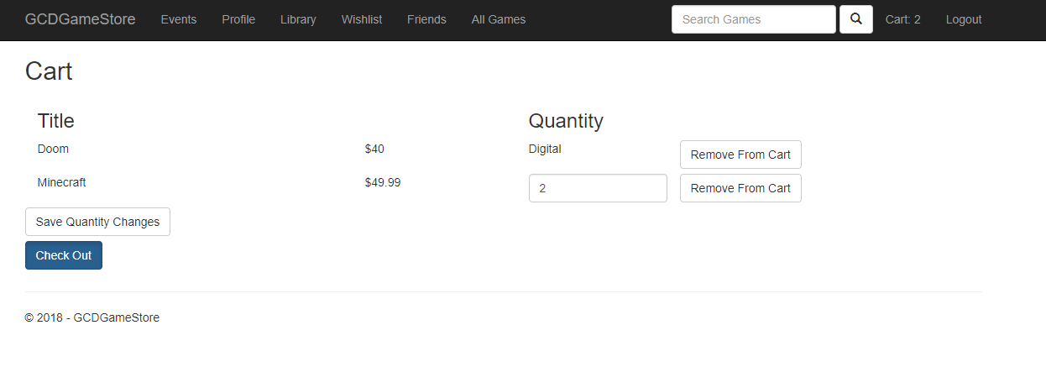

## Check Out

In the cart page, click “Check out” button to confirm order before payment.



Checkout detail is displayed.

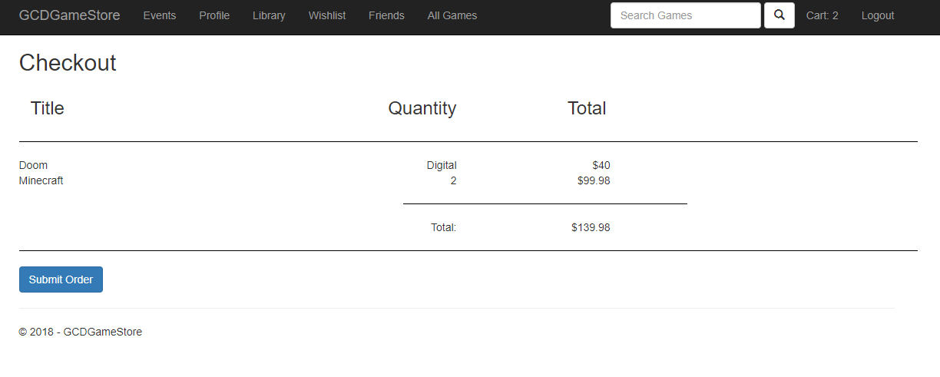

## Submit order

In the checkout page, click “Submit Order” button to submit this order.



Once the submission is successful, the library page will be displayed, and the bought game will be showed.

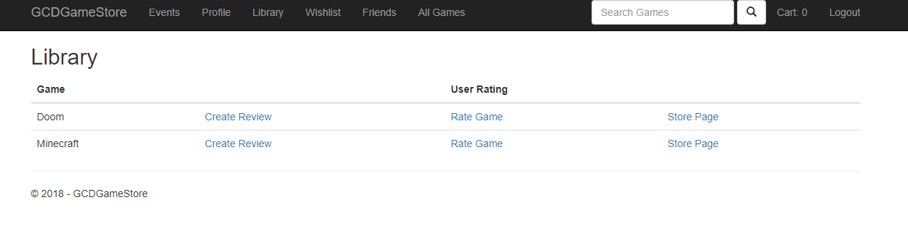

# Friends

## View Friends

Once logged in, click the “Friends” button in the navigation bar.

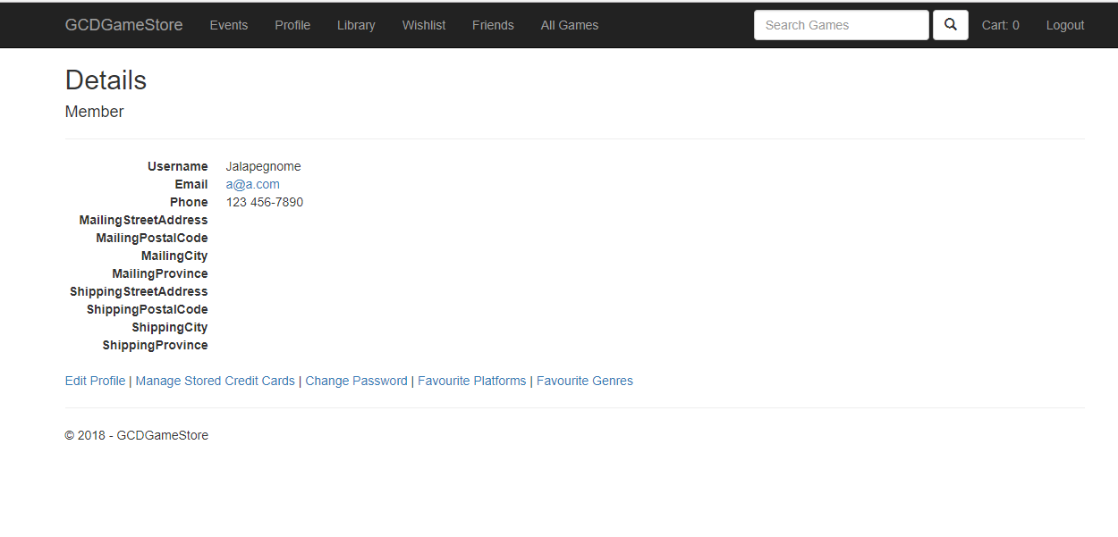

The friends list is displayed.

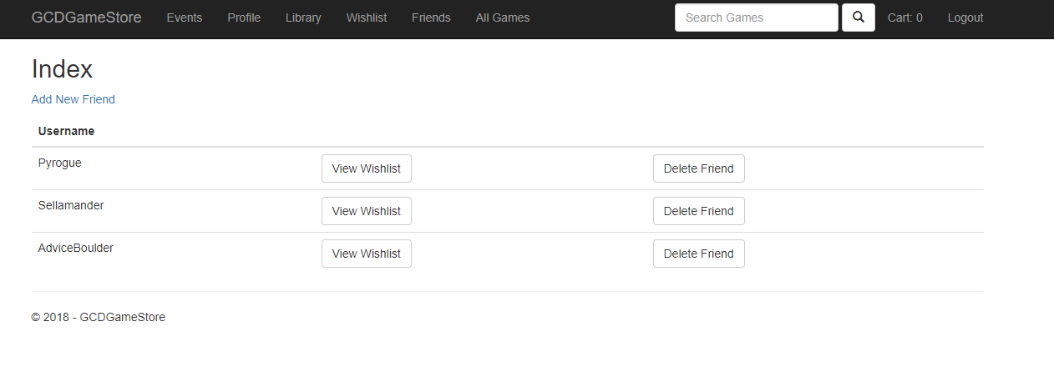

## Add Friend

In the friends list page, click “Add New Friend” to go create friend page.



In create friend page, enter the member’s name to add to the friend list, and then click “Create” button to finish adding friend.

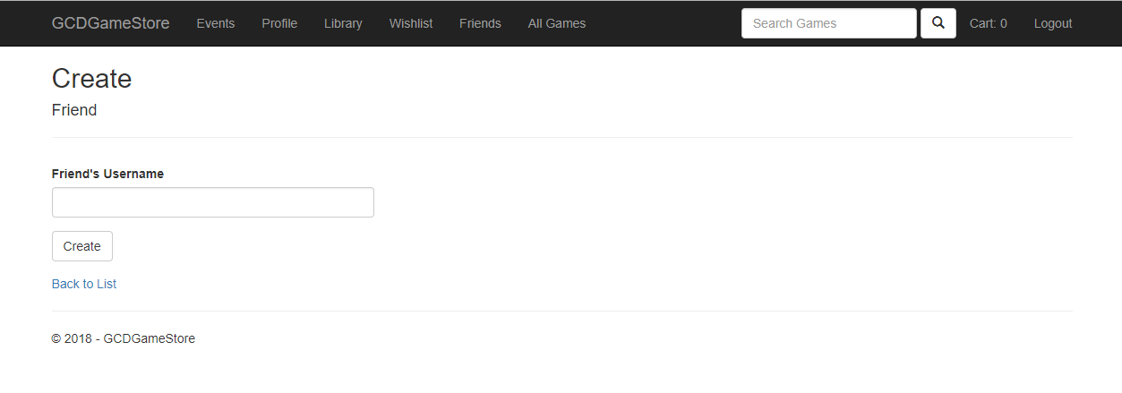Once the friend is added, the friend list page will be loaded.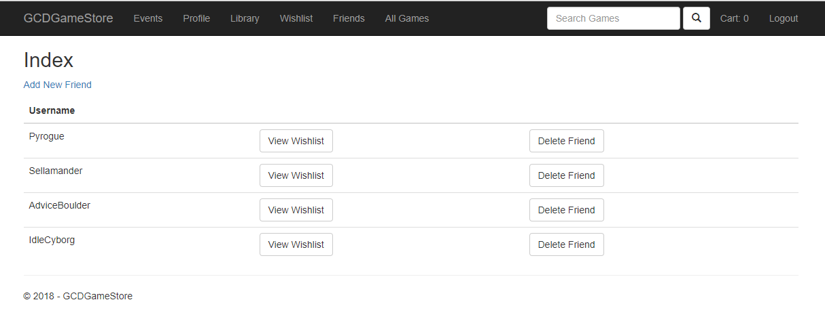

## Delete friend

In the friend list page, click the “Delete Friend” button to remove one friend from the friend list.



The friend has been removed from the list, and the updated friend list page is displayed.

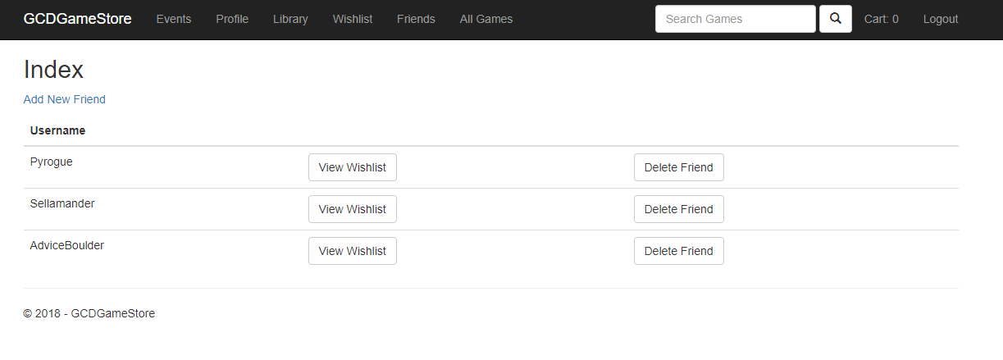

## View friend’s wish list

In the friend list page, click “View Wishlist” button for view one friend’s wish list.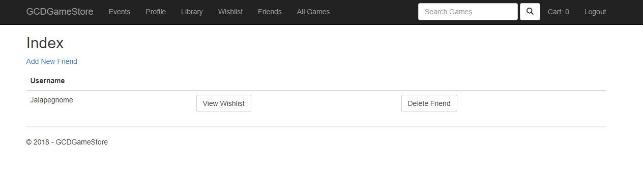

The page display Jalapegnome’s wishlist.

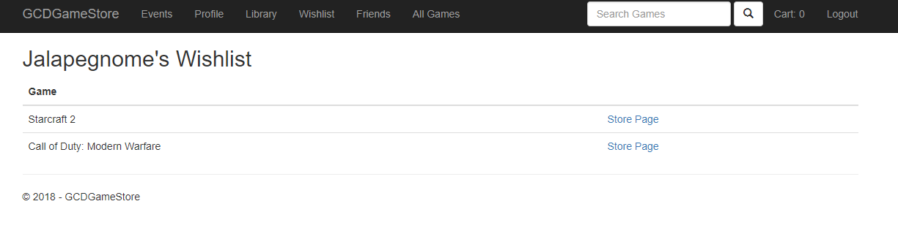

# Library

## Rate game

Once member logged in, Click “Library” button in the navigation bar to go library page.



In library page, the member’s game list displayed, click “Rate Game” for rating Doom. Rating game page will be displayed.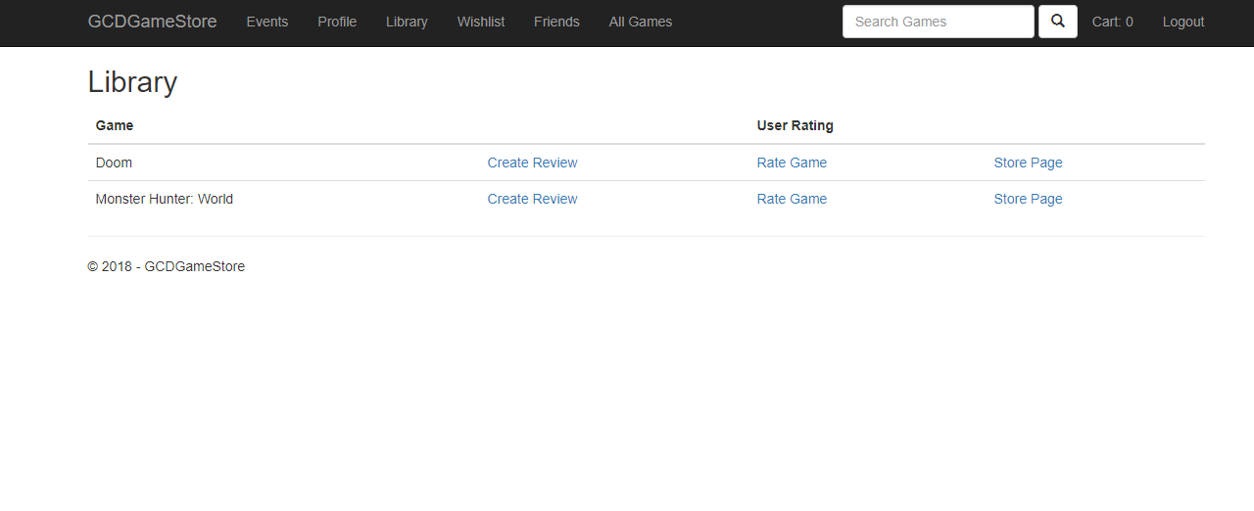

In rating game page, enter any number between 1 to 5, and click “Create” button. Member add a rating for game Doom, and library page will be returned with the rating number.

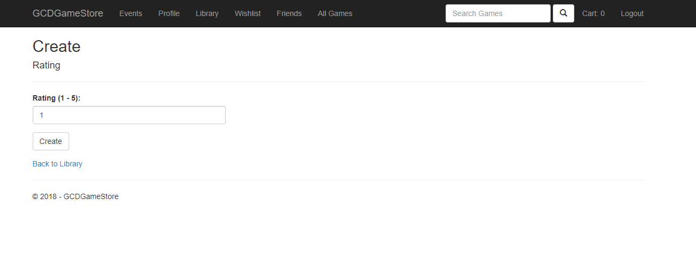The library page is displayed and the in user rating for Doom is changed to 2.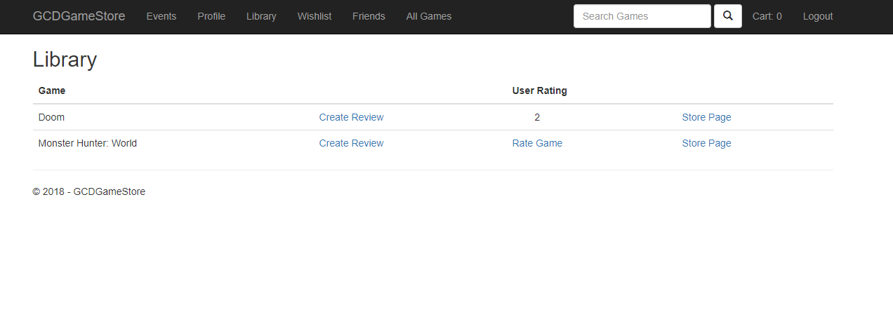

## Add review

Continue with the library page, click “Create Review” for Doom to go create review page.



In create review page, check “Recommended”, if the game is recommended. Entering the review in “ReviewText”, then click “Create” button to finish adding review. The review detail is displayed.

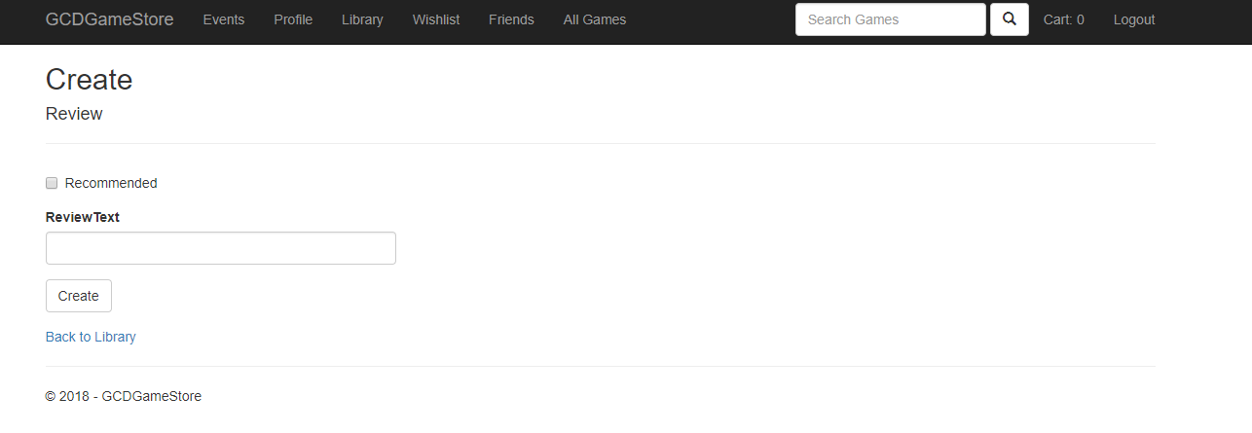

The review detail of Doom return.

